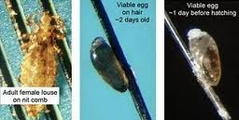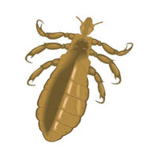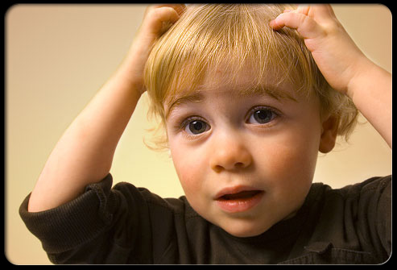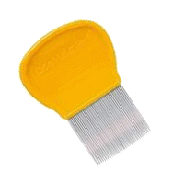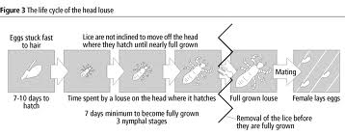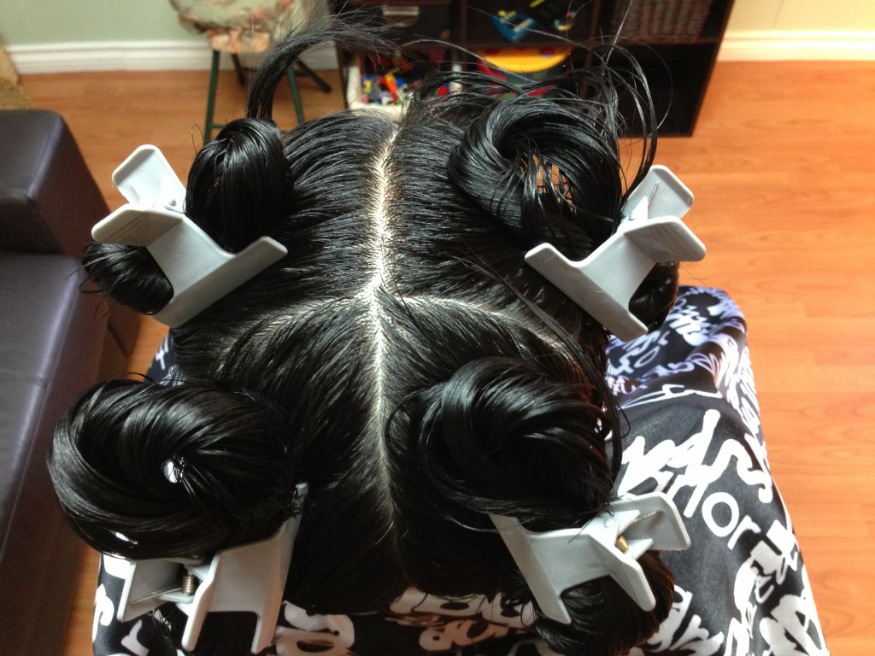 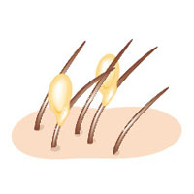

HEAD LICE HELPLINE: (778) 984-5423

liceadvice@liceclinic.ca

Frequently Asked Questions:

**What are head lice?**

Head lice are human parasites that live entirely on your head. Any human with hair on their head is susceptible to catching it.

**What are the first signs of head lice?**

Frequent scratching and/or feeling like something is moving in your hair. An early sign in young children is often sleeplessness, as head lice are nocturnal.

**Can I get rid of lice in a single treatment? So many products claim to do this, but none seem to work.**

Unfortunately, there is no one-time fix for head lice. The protein in the nit glue is chemically similar to the protein in the hair itself, so any solvents that would dissolve the glue would dissolve the hair as well. Manually removing the nits with a high quality comb is the best option. We recommend the LiceMeister© comb.

**What do I have to clean in my home?**

Cleaning for head lice is very minimal. The first day that you discover the infestation and do the first removal is the only day you need to clean for head lice. They cannot live off the human host for longer than two days, and cannot jump, fly, burrow or even walk well on anything but hair. Put sheets, pillowcases and recently worn clothes in the dryer for 30 minutes. Items that cannot go in the dryer can simply be set aside for two days. There is no need to bag or freeze items. Combs, brushes and hair accessories can be washed in hot soapy water, or set aside for two days. Fabric upholstery can be vacuumed or covered in a sheet for two days.

**How can we prevent future infestations?**

The best way to avoid catching head lice is to contain your hair. Head lice is passed by hair-to-hair contact 90% of the time, so preventing that is key. The earlier a case of head lice is detected, the easier it is to remove, so the Lice Clinic recommends that parents screen their children regularly as part of their hygiene routine.

You can reduce risk by:

* Screening for head lice on a regular basis
* Wearing hair up at school, work and play
* Not sharing hats, combs, brushes or accessories
* Bringing own pillow and sleeping bag to sleepovers
* Keeping hats or fur-lined hoods in bags at school
* Protecting hair when using public upholstered seats

What to look for:

When you’re screening for head lice you’re not just looking for live lice. Head lice are very small and move very quickly. They detect movement and light, so as soon as you start looking at one side of the head, they’ll run to the other side. You can more easily confirm a case of head lice by finding their nits (eggs) because they are glued to the hair shaft and cannot move when you’re looking for them.

Nits vary in colour from clear to tan to dark brown and are about half the size of a sesame seed. They are found stuck to the hair shaft close to the scalp. They are always oval shaped, have smooth edges, and are cemented to one side of the hair shaft. Dandruff or hair casts are sometimes mistaken for nits, but they are irregularly shaped and easily removed.

How to check for head lice:

Sit your subject in a brightly lit area or in sunlight and use a magnifying glass or visor. Use screening sticks or a separating comb to part the hair looking near the root of the hair for nits. Examine both the top side and underside of each section of hair, remembering that nits are laid only on one side of the hair shaft.

Begin screening on one side of the head at the temple and work around the back of the head to the other temple. Then examine the top and crown of the head and the hairline around the face and ears. If you see anything suspicious, try to move it. If it moves easily, it’s not a nit. If it does not move, use your magnifying glass to check again to make sure that it is oval shaped and stuck to only one side of the hair shaft. If it is cemented to the hair and doesn’t come off easily it is likely a nit. Have a closer look for more nits in the area as the female louse usually lays in groups.

Help with Head Lice

For many families, finding head lice can be an overwhelming experience that causes undue stress and embarrassment. But just a few key facts and the right tools can make the removal process simple and manageable.

Comb-out the immature phases

Immature lice (nymphs) moult three times over the course of 7-10 days

Nits hatch

after 7-10 days

mate

If lice reach maturity, they will begin to reproduce and lay more nits

How to break up the life cycle:

The entire life cycle of a head louse is 32-35 days, but they can only reproduce as adults – for about the last half of their life cycle. Schedule all your comb-outs to remove the nits and baby lice before they get to the point of adulthood. Comb as directed or every three days until your first completely clear comb-out. Then wait 7-10 days and do another one. Two clear comb-outs 7-10 days apart ensures you are finished. It is essential to achieve these two clear comb-outs, or the infestation could continue.

How to get rid of head lice:

It is essential to remove all live lice and every one of their nits from the hair. Even if you use a pesticide shampoo to kill the majority of the live lice, it will not kill or remove any of the nits or newborn nymphs. The nits will go on to hatch and your infestation will continue. This is why people can struggle with head lice for weeks and even months. Therefore, the Lice Clinic recommends omitting the pesticide step and removing all lice and nits using the Wet Combing Method. There is no quick fix to getting rid of head lice. The average case takes two to three weeks to clear.

The Wet Combing Method of removal is the safest, easiest, and most cost-effective way to eliminate a case of head lice. This method does not use any chemical treatments and focuses on breaking up the life cycle of the lice. Comb-outs are done using only hair conditioner and a high-quality lice comb. The first comb-out removes over 95% of the infestation, leaving behind only microscopic nits and possibly a few newborn nymphs, which are removed in subsequent comb-outs, long before they are able to reproduce.

Wet Combing Instructions:

1. Liberally apply conditioner on DRY hair, saturating the hair and scalp.
2. Comb conditioner through hair with the detangling comb to further distribute the conditioner and remove knots.
3. Use a tail-pin comb to separate the hair into four quadrants, and use the hair clips to secure each section.
4. Clean one quadrant at a time. Undo the first one, using the tail pin comb to take out a small horizontal section at the bottom of the hairline. Clip the rest of the section back up and out of your way.
5. Position the teeth of the lice comb as close to the root of the hair shaft as possible, and then pull the comb trough the full length of the hair from root to tip. Comb from both the underside and topside of each section, as nits are laid on only one side of the hair shaft.
6. After combing each section, wipe the conditioner off the comb onto a white cloth and spread it out. Take note of how many nits and live lice you find so that you can monitor your progress.
7. Inspect all sides of the small section of hair for the nits or live lice. If any lice or nits remain, comb again or use the tweezers to pull them off.
8. Continue taking small sections working your way up to the top of the head until all the hair in the quadrant has been combed. Comb through the entire quadrant a few times then clip it back up and move on to the next quadrant.
9. Once all four quadrants have been thoroughly combed, take out the clips and comb over the areas where the parts were.
10. Finish by passing the lice comb through the entire thickness of the hair working from root to tip, all the way around the head. With long hair, hold it as though making a ponytail. Continue to wipe the conditioner onto a white cloth and inspect for lice and nits. This is the step that can be used in your future monthly comb-outs to detect a new head lice infestation early.
11. Rinse out the conditioner and style as usual.
12. Soak all tools in hot soapy water, wash towels and rags in hot water and a hot dryer. The LiceMeister© can be boiled for one minute to sterilize.
13. Follow these instructions as directed or every three days until you have combed out completely clear two times, 7-10 days apart.
14. Once you are completely clear, check children for nits once a week on dry hair, and do the ‘final’ comb-out once a month. This will ensure that any future infestations are found very early and will be very easy to remove.

Early detection is the connection!